**How to use VPrint**

In order to use VPrint please follow these instructions.

1. Start the program and get logged in. Use your TRS account.

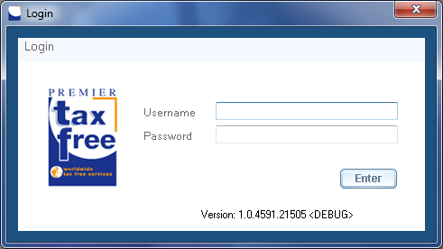

1. The program main screen appears.

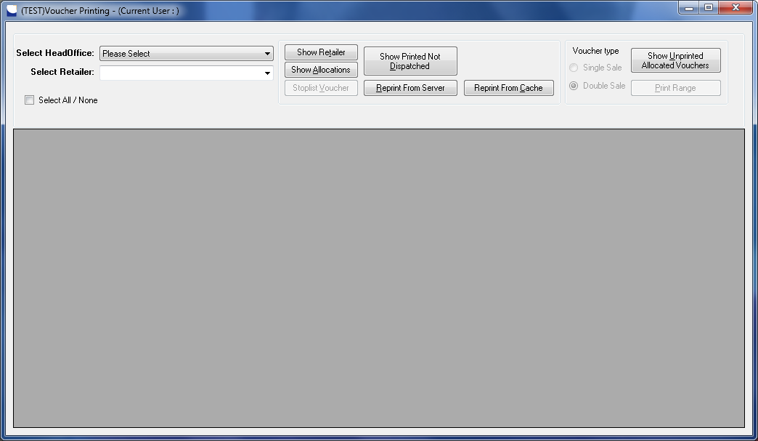

1. Select Report Type

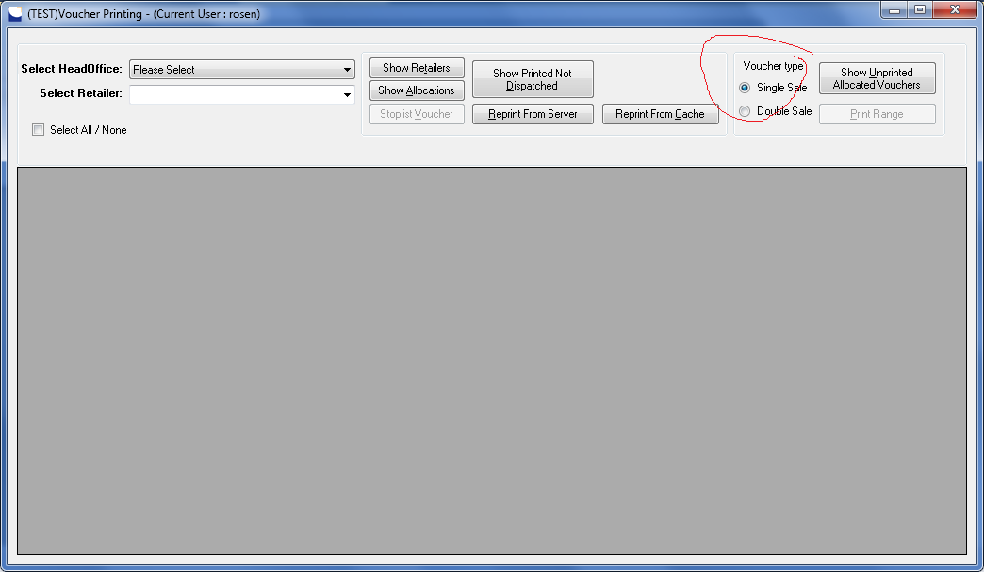

1. Select the head office and click on “ShowRetailers”

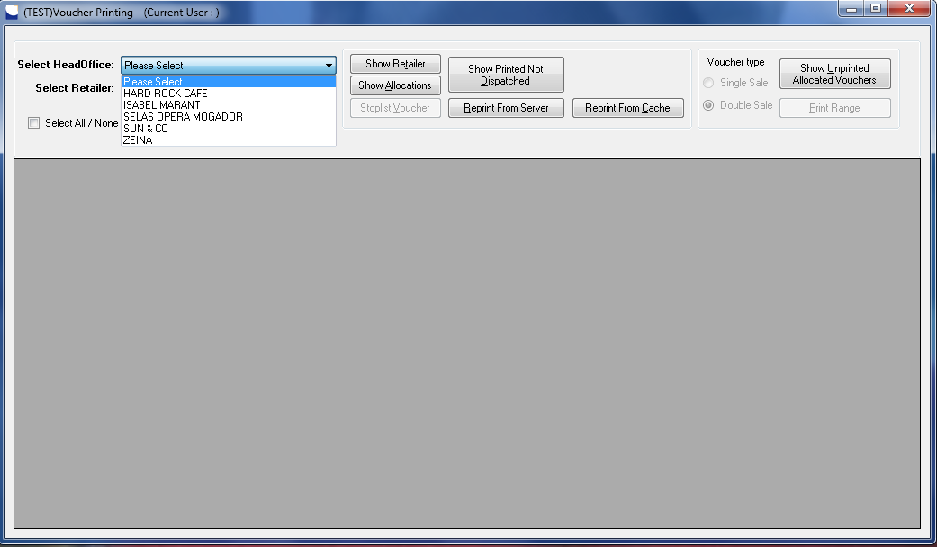

1. Select Retailer

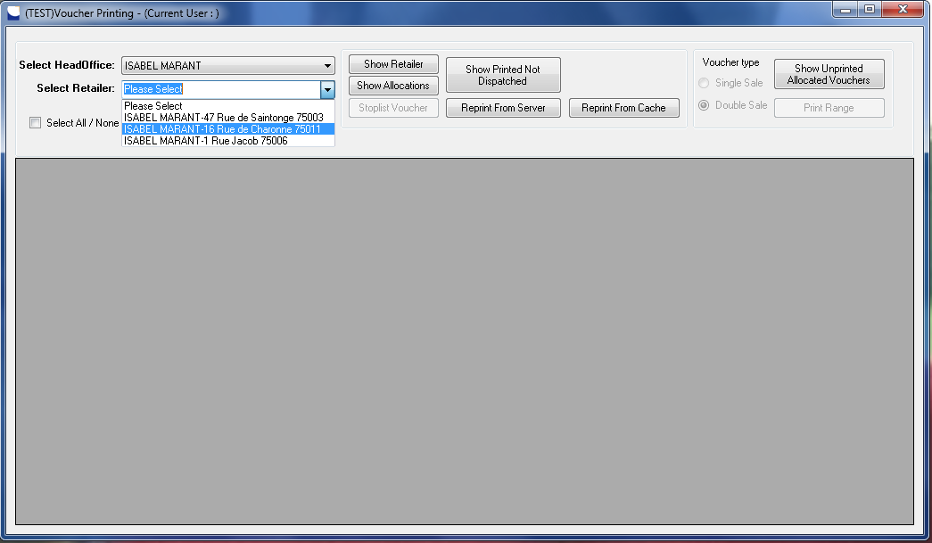

1. Click on “Show Unprinted Allocated Vouchers”. Select allocations you what to print and click on “Print Range” button.

